Level 4 DevOps Engineer Apprenticeship

## **Version Control**

| **Version #** | **Date** | **Updated by** | **Description** |
| --- | --- | --- | --- |
| V1.2 | July 22 | Catherine | Changing wording from Releases to stages |
|  |  |  |  |
|  |  |  |  |

## 

## 

## **Contents**

Contents **2**

**Overview of Devops Level 4 apprenticeship** **3**

Makers Goal for you 3

Devops Overview 3

Job roles might include 4

Links 4

**Assessment 1 - Project and Practical Assessment** **4**

Brief overview 4

The project 4

Delivery 5

Links 6

**Assessment 2 - Professional discussion** **6**

Brief Overview 6

Delivery 7

Links 7

**Overview of Knowledge, Skills and Behaviours** **7**

**Grading and assessment** **8**

Reasonable adjustments **8**

## **Overview of Devops Level 4 apprenticeship**

### Makers Goal for you

Here at Makers we want to train IT professionals who can work equally and effectively in both development and DevOps roles; with DevOps being their specialism and vocation.

We want to continue to train our apprentices so they deliver value from Day One of placement.

Our bootcamp continues to be self led learning that is agnostic, problem solving focused and authentic.

### Devops Overview

This occupation is found in a wide and diverse range of public and private sector organisations, from tech start ups through government departments to multinationals. Essentially any organisation of any size that builds and/or operates modern IT services.

The broad purpose of the occupation is to enable organisations to get valuable working software out in front of active users, both external and internal, frequently and safely, reducing time to market, delivering increased value - both with respect to the end user and the business - and improving the quality of digital services.

The DevOps Engineer encapsulates both disciplines, requiring the individual to understand and appreciate how their code functions when being used in the real world and troubleshoot any issues that may arise, while taking a cloud-infrastructure focused perspective. This means taking responsibility for all aspects of the development and operations process - the design, build, test, implement, release and continual iteration of products. Utilizing the advantages of Cloud computing to enable infrastructure to be defined in code moves the operations side away from traditional system administrator roles which are focused on troubleshooting traditional infrastructure-as-hardware. The convergence of these two topics drives DevOps culture and ways of working and creates the need for the new role of DevOps Engineer that works within the delivery team. The DevOps Engineer applies all the DevOps culture and software engineering disciplines to codified infrastructure.

In their daily work, an employee in this occupation interacts with other members of agile development teams, other areas within the organisation’s IT department and business areas, as well as 3rd-party suppliers. This is an office based or remote working role, with co-location preferable.

### Job roles might include

DevOps Engineer, Infrastructure Engineer, Platform Engineer, Reliability Engineer, Site Reliability Engineer, Build and Release Engineer, Automation Engineer, Full Stack Developer, Deployment Engineer

### Links

For help on keeping track of your daily work and preparing use the [Retro diary](https://docs.google.com/document/d/1mr9pyup8uceIqZKyberYsT8wqX7KNDSIIX1ENNsHKWs/edit?usp=sharing)

For an overview from The Institute for Apprentices [Link to the IFATE EPA guidance](https://www.instituteforapprenticeships.org/media/4069/st0825_devops_engineer_l4-ap-for-publication_050320_qm_minor-amend-190320.pdf)

## **Assessment 1 - Project and Practical Assessment**

### Brief overview

The apprentice will scope out and provide a brief summary of what the project will cover and will submit this to the EPAO at the gateway. This should demonstrate that the work-based project will provide sufficient opportunity for the apprentice to develop the piece of code and meet the assessment criteria. The brief summary is not assessed and will typically be no longer than 500 words

The brief summary needs to outline the project plan, including high level implementation steps and associated timeframes, as well as the date the work-based project has to be submitted to the independent assessor, taking into account the deadlines stipulated within this end-point assessment plan.

The EPAO will sign off the title of the project report in consultation with the employer within 2 weeks of the Gateway to ensure sufficient scope to develop the piece of code and meet the KSBs mapped to this assessment method.

### The project

A piece of code will be developed, based on a post-gateway work-based project, and should cover the following:

• operating a performant, secure and highly available platform

• a successful deployment of code from source to the end user

• satisfy the functional and non-functional requirements defined by the work-based project

The piece of code developed must have a real focus on continuous delivery, code branching and management with many developers working on branches of the same code base simultaneously. It is also expected that the practical assessment shows code and data management, use of DevOps tools and pipelines and use of multiple environments.

The end-point assessment organisation will arrange for the practical assessment to take place, in consultation with the employer. Practical assessments must be carried out over a maximum assessment time of 3 hours. The practical assessment may not be split, other than to allow comfort breaks as necessary. The independent assessor may conduct and observe only one apprentice during this assessment method. The rationale for this assessment method is: This method allows direct testing under controlled conditions. This occupation is very much about 'learning by doing' and this method provides the best way of assessing the required level of competence. The scope of the practical assessment will require the apprentice to put into practice the mapped KSBs, demonstrating competence in designing, building and iterating a piece of cloud native infrastructure - i.e. infrastructure-as-code.

### Delivery

A work-based project title and brief summary will be submitted to the EPAO at the gateway. This will be checked and advice given by Makers. The EPAO will sign off the project title and brief summary in consultation with the employer within two weeks of the gateway. Once the project title and brief summary have been signed off by the EPAO, the project, piece of code and preparation for the practical assessment must be completed and submitted to the EPAO within 13 weeks. It is envisaged that the project and piece of code will typically take 12 weeks to undertake and the practical assessment preparation will typically take an additional 1 week.

The apprentice will need to consider the availability of company and external resources required to complete the work-based project. They must also ensure they are fully aware of the KSBs the work based project intends to assess as that is what the grading of the practical assessment and questioning will be based on.

Whilst completing the work-based project the apprentice should be subject to the supervision arrangements outlined below:

1. Normal line management controls. The apprentice may work as part of a team which could include technical internal or external support however the project will be the apprentices own work and will be reflective of their own role and contribution. The employer is responsible in verifying that the work submitted is that of the apprentice.
2. The employer should allow the apprentice 2 days per week to work on their project during the EPA period.

As an outcome of the project the apprentice must produce sufficient evidence of the form, technical breadth and specific technical outputs of the work in order that the independent assessor can familiarise themselves with the project output (i.e. the piece of code) prior to the practical assessment.

Therefore the project submitted to the EPAO as an integral part of this Assessment Method must include the following:

1. on ‘form’: an architectural diagram (in a structured or ad-hoc notation) or other artefact which shows high level system structure
2. on ‘technical breadth’: a short analysis, maximum 300 words, of which project areas provide evidence against which KSBs
3. on ‘specific technical outputs’: the independent assessor will need to be provided with implementations which cover all techniques used. These may include source code, deployment/ system build scripts or configuration files and should be communicated to the independent assessor through access to cloud services, an archive of files or in screenshots/videos/documents

### Grading and assessment

EPAOs will create and set open questions to assess related underpinning KSBs. The questions can be asked both during and after the practical assessment. The independent assessor can ask up to 16 questions generated from an EPAO question bank and generated by themselves (2 questions for each of the 8 themes within this assessment method, see table below). Questioning must be completed within the total time allowed for the practical assessment.

The 8 themes are Code Quality, Meeting User Needs, The CI-CD Pipeline, Refreshing and Patching, Operability, Data Persistence, Automation, Data Security

| **Grading Criteria** |  |  |
| --- | --- | --- |
|  | **Fail - Pass criteria not met** |  |
|  | **Pass - Meets all the pass criteria** | **Distinction - meets all the distinction criteria** |
|  | **Code Quality** | |
|  | Writes code, both general purpose and  infrastructure-as-code (including cloud infrastructure)  that is correctly versioned and easy to merge, while  adhering to the principles of distributed Source  Control.  Demonstrates an iterative approach to evolving code  consistent with cloud security best practice,  evidenced by a lack of vulnerabilities and that all  dependent components are present at run time.  Writes code around unit tests, including the  appropriate use of test doubles and mocking  strategies.  Explains troubleshooting methods used to identify  and resolve issues and gives an example of  identifying and remediating an issue that  compromised code quality.  **(K2, K5, K7, K14, S9, S11, S14, S17, S18, S20,**  **S22)** |  |
|  | **Meeting User Needs** | |
|  | Writes user stories that are understandable to a wide  range of stakeholders, stand up to scrutiny and lend  themselves to a solution based on common architectural  patterns - i.e. reducing the number of moving/redundant  parts; passes all acceptance  tests.  The piece of code meets the ‘must have’ identified  functional/non-functional user needs encapsulated in  the acceptance criteria for the task.  Creates a quality product in terms of Mean Time To  Recovery (MTTR) - i.e. reduced time to fix bugs.  (**K4, K10, K21, S3)** | Produces a piece of code that meets  the ‘should have’ identified  functional/non-functional user needs encapsulated in the  acceptance criteria for the task. |
|  | **The CI-CD Pipeline** | |
|  | Builds a fully functioning, automated CI-CD pipeline  with all tests passing.  Evidences a code commit progressing seamlessly  from a build artefact to the end user.  Explains the pipeline capability, including the  benefits of frequent merging of code, in terms of  Continuous Integration/Delivery/Deployment.  **(K1, K15, S15)** |  |
|  | **Refreshing and Patching** | |
|  | Deploys immutable infrastructure that enables the  regular recycling of servers and refreshing of  associated software based on manual processes.  **(K8, S5)** | Fully automates the refreshing and  patching process |
|  | **Operability** | |
|  | Instals and manages monitoring and alerting tools  that provide coverage of the infrastructure and  applications, including RAM and CPU utilisation,  application error rates and availability (health check).  Configures appropriate alerting thresholds and  visualisations. Interprets these in terms of failure  scenarios and remedial/follow up actions taken to  deliver continuous improvement.  **(K11, S6, S19, B3)** | Introduces custom metrics that  provide additional improvement  areas.  Explains how these improvement  areas may be interpreted,  implemented and delivered. |
|  | **Data Persistence** | |
|  | Employs and operates an appropriate data  persistence technology, such as database,  configuration/infrastructure state management to  meet non-functional and functional needs.  Explains troubleshooting steps taken to locate issues  across the end-to-end service.  **(K12, S7)** |  |
|  | **Automation** | |
|  | Introduces process efficiencies by automating the  setting up/deploying of the project (infrastructure and  applications) from scratch, both locally, including all  tests, and to a hosted environment.  **(K13, K17, S12)** | Identifies an additional opportunity  and introduces automation that  reduces overall effort. |
|  | **Data Security** | |
|  | Builds in security so that all data in transit is  encrypted and secure.  Explains the types of threats and the rationale  behind the decision to either encrypt data at rest or  not.  **(K16, S10)** |  |

### Links

For more guidance on the [Project](https://drive.google.com/file/d/1Jgv7VyIxlsnWDZ5YvhRFhKoe3BNrCU_V/view?usp=sharing)

## **Assessment 2 - Professional discussion**

### Brief Overview

This assessment will take the form of a professional discussion which must be appropriately structured to draw out the best of the apprentice’s competence and excellence and cover the KSBs assigned to this assessment method. It will involve the questions that will focus on activity and analysis of given scenarios; for example, ‘the benefits of pairing with other developers’ or ‘selecting the most appropriate problem solving technique to address a given problem’.

The rationale for this assessment method is: It ensures the apprentice can demonstrate the application of evidence to DevOps practices and their own continuing professional development. This will allow some KSBs which may not naturally occur in every workplace or may take too long to observe to be assessed and the assessment of a disparate set of KSBs.

A portfolio of working examples should be available for each apprentice that demonstrates where each of the KSB’s have been met. The purpose of the portfolio is to demonstrate your competence across the Knowledge, skills and behaviours for the Devops apprenticeship. The final portfolio is produced for 2 main reasons - Inform all stakeholders (the employer, Makers and the apprentice) that you are ready to be considered for EPA (End Point Assessment) and to prepare you for your final professional discussion. This is not a piece of work that is marked and graded towards your apprenticeship but must be completed to demonstrate your ability.

### Delivery

The EPAO should provide the apprentice with 2 weeks’ notice of the professional discussion. The independent assessor will conduct and assess the professional discussion. The professional discussion must last for 60 minutes. The independent assessor has the discretion to increase the time of the professional discussion by up to 10% to allow the apprentice to complete their last answer.

During this method, the independent assessor must combine questions from the EPAO's question bank and those generated by themselves.

The apprentice may use a whiteboard to help with visualising the KSBs; e.g. K18, K19 and K22.

### Grading and assessment

The discussion should not be led by the independent assessor as it involves both the independent assessor and the apprentice actively listening and participating in a formal conversation, giving the apprentice the opportunity to make detailed and proactive contributions to confirm their competency across the KSBs mapped to this method.

The independent assessor will ask a minimum of 8 open questions (one for each category see table below) from the EPAO’s question bank and those generated by themselves sufficient to cover all mapped KSBs. Follow up questions may then be used to draw out further evidence.

The categories of assessment are Organisational Culture, Data Ethics, Problem Solving, The Profession in Context, Tooling & Technology, Continuous Learning & Development, Peer review, Communicating and Knowledge Sharing

| **Grading Criteria** |  |  |
| --- | --- | --- |
|  | **Fail - Pass criteria not met** |  |
|  | **Pass - Meets all the pass criteria** | **Distinction - meets all the distinction criteria** |
|  | **Organisational Culture** | |
|  | Explains how an organisation's culture can both  provide creative freedom and introduce constraints.  Explains the connection between culture and the  organisation’s potential for continuous improvement  with both internal and external parties.  **(K9, K23, S2)** | Explains the mindsets that underpin organisational culture - e.g. outcome versus activity driven, collaboration versus silos, accountability, trust and empowerment and their impact on the organisation.  Assesses the difference between risk avoidance and risk acceptance and how these link to culture |
|  | **Data Ethics** | |
|  | Identifies relevant data protection legislation and  assesses its impact on the ethical use of customer  data, as well as its relevance to emerging  technologies, such as Artificial Intelligence and  Machine Learning.  **(K3)** |  |
|  | **Problem Solving** | |
|  | Identifies different problem solving techniques and  evaluates how they use modelling approaches that  are best suited to each technique in order to gain  consensus as a team.  **(K6, S21)** | Describes how they facilitated an incident postmortem/lessons learned session.  Explains the root cause analysis process. Gains consensus on an improvement plan, including accountabilities and the implementation timeline. |
|  | **The Profession in Context** | |
|  | Identifies the typical multi-disciplinary team roles and  explains how they fit within the organisation and the  wider digital landscape.  Explains how they completed a task, deploying a  flexible, collaborative and pragmatic approach with  peers and other stakeholders.  Describes examples of different communication  methods used when dealing with internal and  external stakeholders  Explains how they have acted in an inclusive and  professional manner.  **(K18, K19, K22, S8, B4)** |  |
|  | **Tooling & Technology** | |
|  | Explains the difference between the various types of  implementation - on premise v SaaS, open source v  enterprise, bespoke v off-the-shelf.  Explains an example of having utilised the right type  of tool for a particular task, describing the pros and  cons of the alternatives.  **(K24)** | Justifies their choice of tooling and the potential  impact of making an alternative choice explaining the cause and effect of making the wrong decision. |
|  | **Continuous Learning & Development** | |
|  | Explains the CPD undertaken by themselves in order  to keep up with cutting edge technologies and  maintain appropriate certifications.  Explains how they invest in others continuous  learning and activities and the impact this has on  their own development.  **(K25, S16, B2)** | Gives examples of how their CPD has had a positive  impact on theirs and their team’s work.  Explains how this has helped them perform their role better  and make better technology choices |
|  | **Peer review** | |
|  | Explains the benefits, in terms of security and overall  quality, of subjecting written code to the scrutiny of  others. Explains how they collaborate on code  through pair/mob commits.  **(K20, S13)** |  |
|  | **Communicating and Knowledge Sharing** | |
|  | Explains when they have:  a) lead a demonstration or discussion in an  engaging manner, communicating at the right  level to suit technical and non-technical  audiences.  b) worked collaboratively to share knowledge  through, for example, blog posts and pairing  on tasks.  **(S1, S4, B1)** |  |

### 

### 

### Links

For more guidance on the Project see our guidance document on [Project of working examples](https://docs.google.com/document/d/1i0wFdoK4EmIEaozmQG-w2XzdkmN7KRSnXAwu8IKbpbE/edit?usp=sharing)

## **Overview of Knowledge, Skills and Behaviours**

Here is the link to all the knowledge skills and behaviours as a spreadsheet so you can see them broken down into the 2 assessment sections as well as the 2 grading criteria

[DevOps Engineer L4 Duties KSBs and Assessment Methods .xlsx](https://drive.google.com/file/d/1WyQZVNbKFocBGGk_rOgJXVO_BZi0IevE/view?usp=sharing)

## Grading and assessment

On this spreadsheet there is a worksheet that outlines the grading for each of the 2 assessment methods. This identifies the pass criteria and the distinction criteria. The final grade is worked on as shown below:

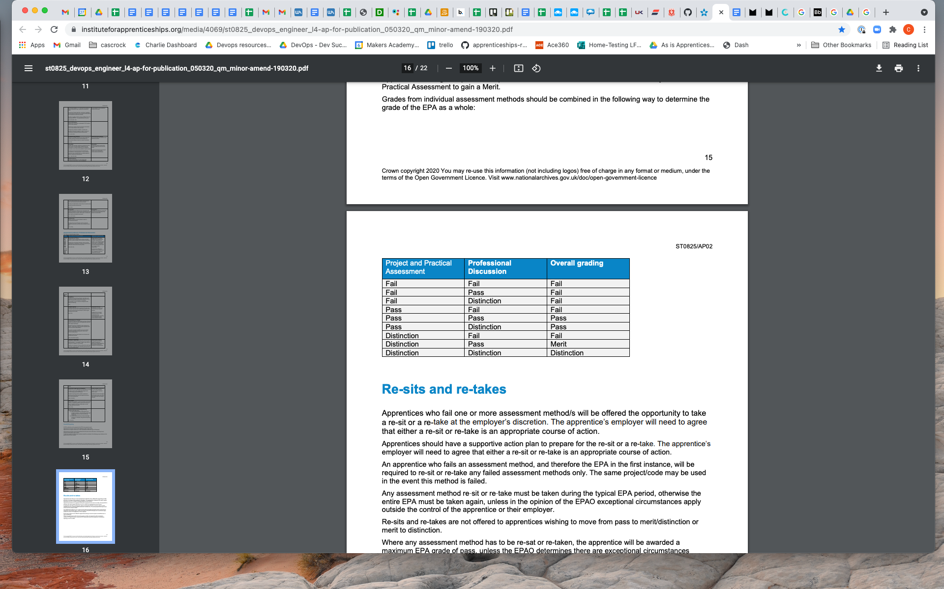

## 

## 

## Reasonable adjustments

The EPAO must have in place clear and fair arrangements for making reasonable adjustments for this apprenticeship standard. This should include how an apprentice qualifies for reasonable adjustment and what reasonable adjustments will be made. The adjustments must maintain the validity, reliability and integrity of the assessment methods outlined in this assessment plan. Please ask your placement coach for more information on this.